|  |  |  |  |  |  |
| --- | --- | --- | --- | --- | --- |
| Date | 22-Aug-26 | | | Tester Name | Andrew McLaughlin |
| Environment | Penfax - Test | | | Login used |  |
| Operating System | Select OS | Version: | Update: | | |
| Software Used | Select Software | Version: | Update: | | |
| Select Software | Version: | Update: | | |
| Release version | 22.3.0 | | | | |
| Title | Death – Calculates proper pension amount | | | | |
| Test Type | Regression | | | | |
| Test Scenario | Death – Calculates proper pension amount | | | | |
|  |  | | | | |
| Expected Results |  | | | | |
| Pass/Fail | Pass | | | JIRA# | N/A |

Describe your steps with screenshots:

Member is with PSSP and has a bridge 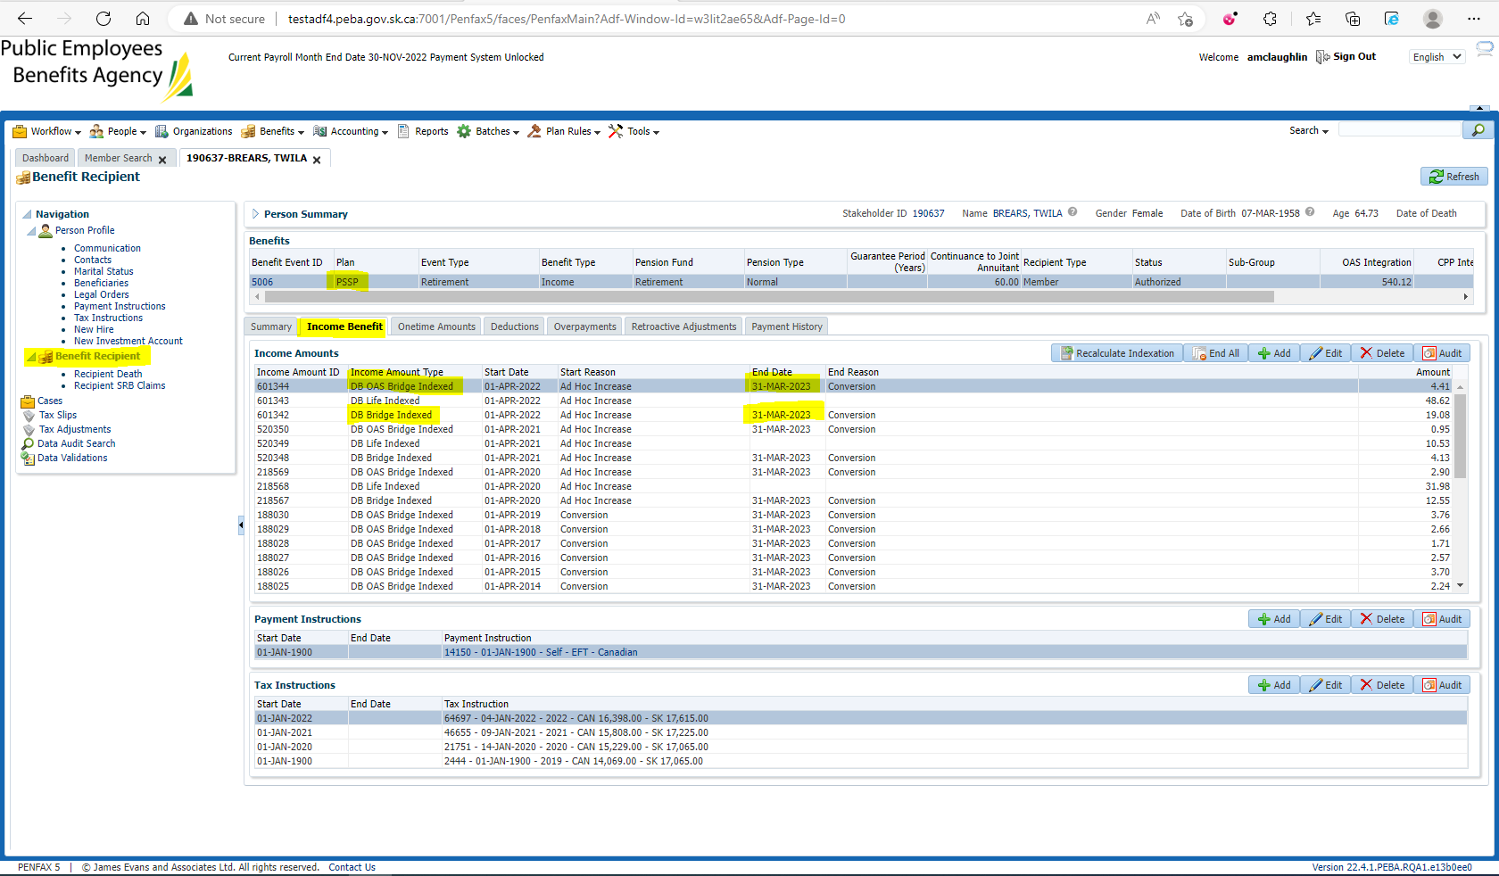

Pension amount is $3,991.20 with a 60% JA 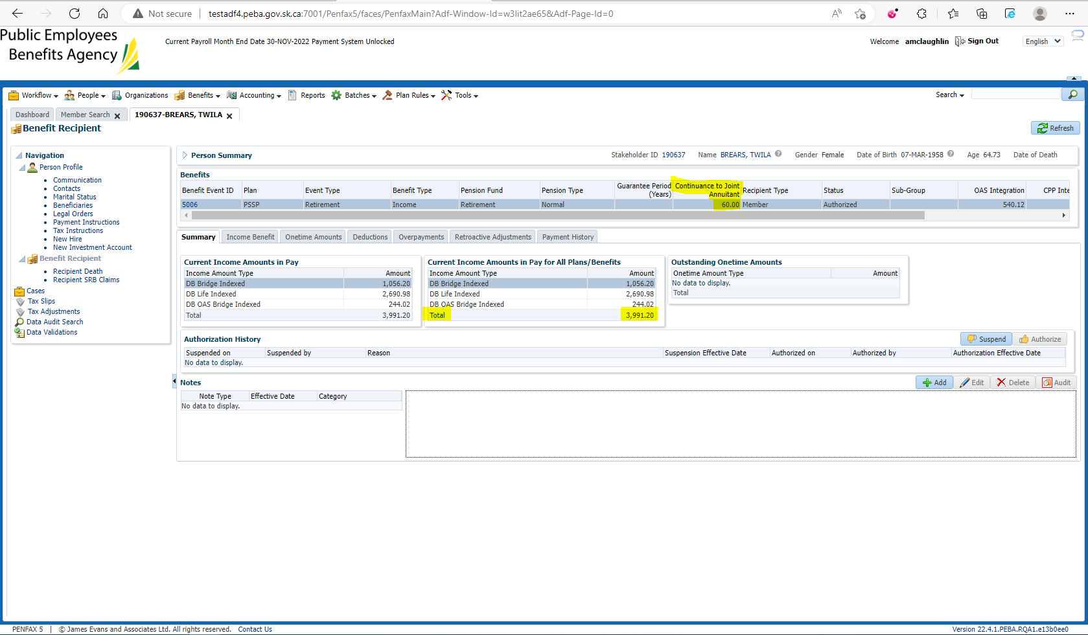

Enter Death Date 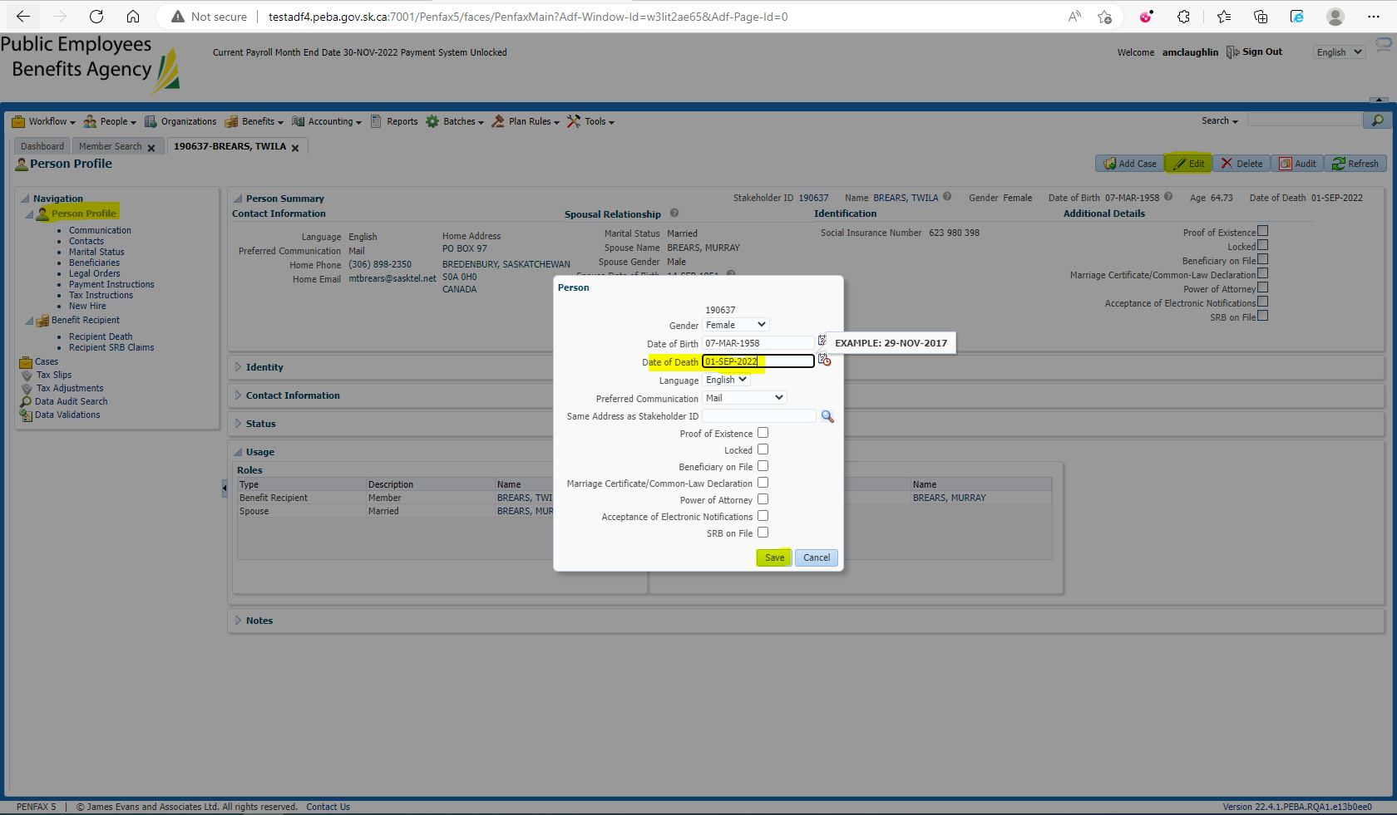

Add the spouse to the Benefit Recipients in the Benefit Event effective 1st day of month after death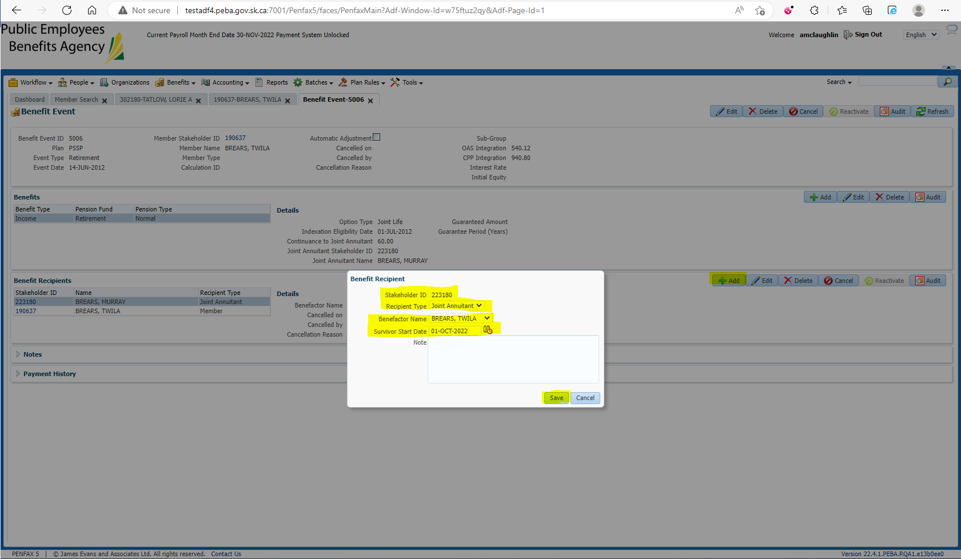

Open the Death Calc 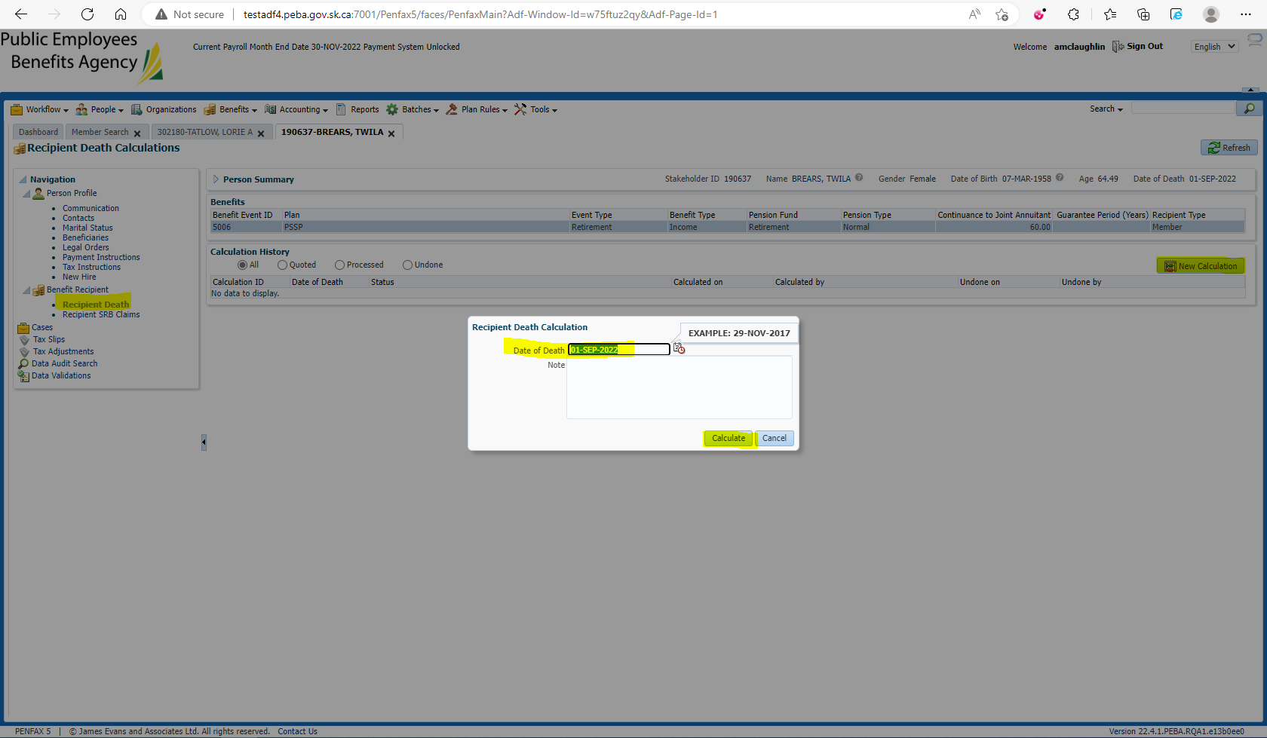

Process x2 and Process Recipient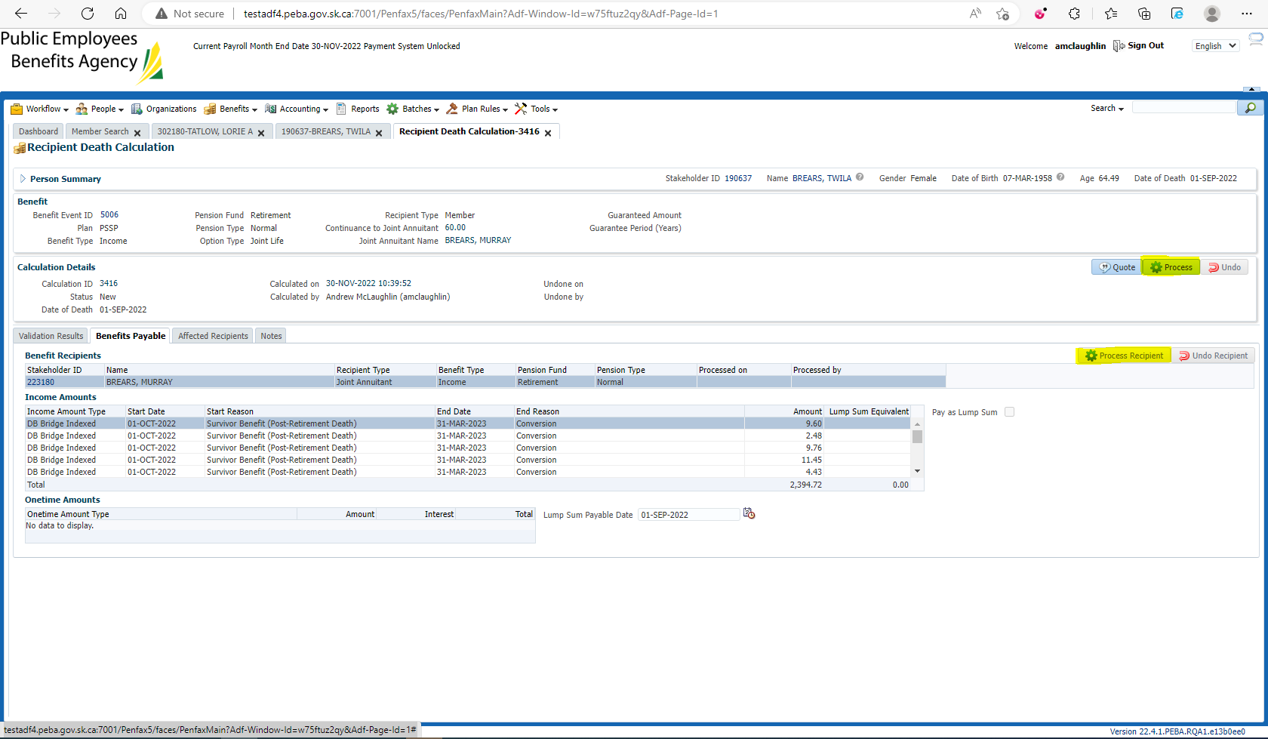

Verify under the spouse’s Benefit Recipient that the pension amount is correct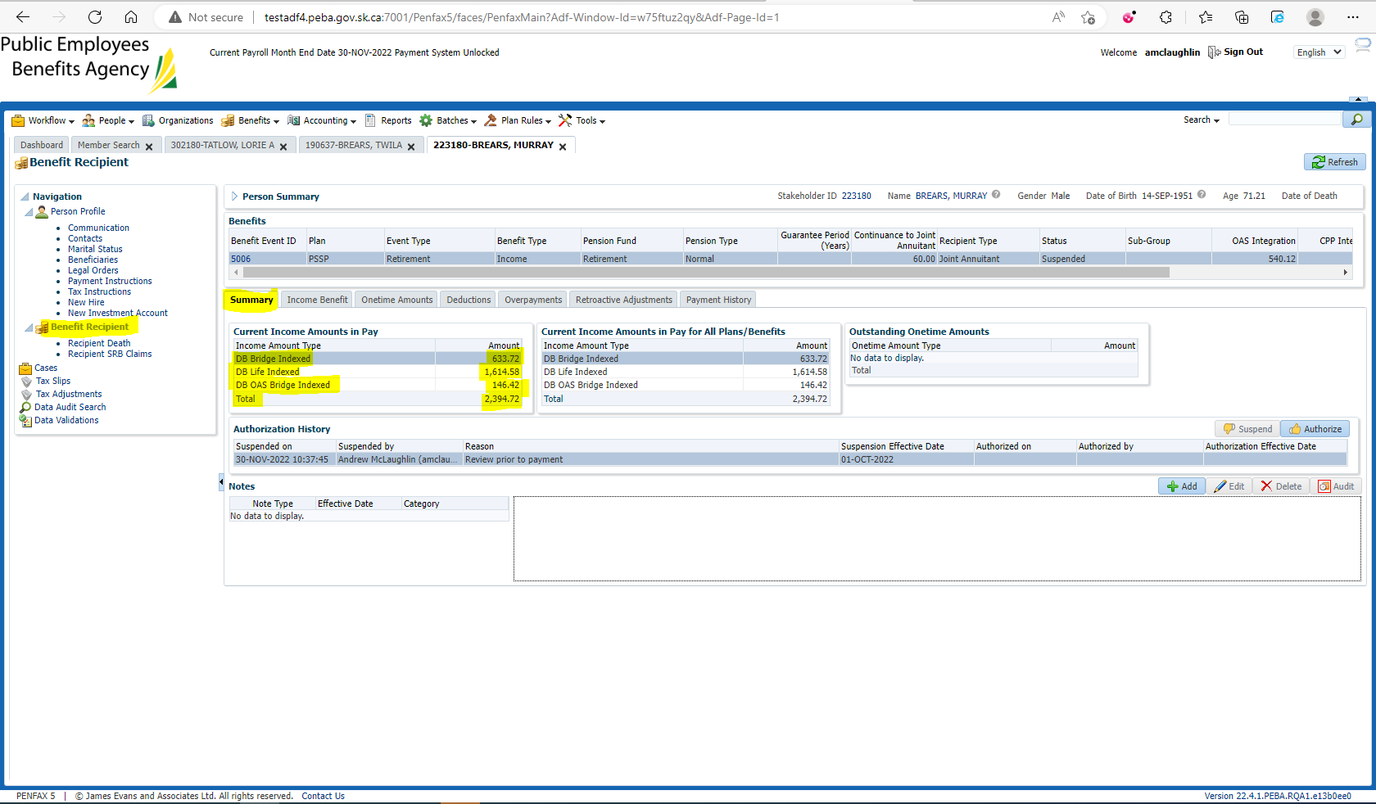

$1,056.20 * 0.60 = $633.72

$2,690.98 * 0.60 = $1,614.58

$244.02 * 0.60 = $146.42